
COALHURST HIGH SCHOOL Box 978
Coalhurst, AB
Principal Athletic Director T0L 0V0
Charlene Grimes Dayna Craddock Phone: (403) 381-4812
Charlene.grimes@pallisersd.ab.ca dayna.craddock@pallisersd.ab.ca Fax: (403) 381-3011

MEMORANDUM

To: Austin Davenport ………………….………………………..Kate Andrews JV
Tyler Speelman ……………………………………………..St. Michaels
Jeff Van Raalte.….…………………………………………..Coaldale Christian
Greg Rollingson……………………………………………...Nobleford
Barry Smith ……………………………………………………Senator Gershaw
Randy Whitehead…………………………………………..Mathew Halton
Spenser Wenzel ………………………………………….....Warner
Ben Swen….. …………………………………………….…...Coalhurst

From: Dayna Craddock Tournament Director

Re: TROJAN CLASSIC BOYS’ BASKETBALL TOURNAMENT
(tournament draw is on page 5 of this document)

We are pleased that you have accepted the invitation to participate in our tournament that is scheduled for Friday and Saturday, December 1 and 2, 2017. We feel that we have been able to enlist an excellent roster of teams and we are looking forward to a great weekend of Basketball.

Enclosed you will find a copy of the tournament draw and other relevant tournament information. Everyone is guaranteed 3 games.

All teams will share change rooms in the gym.

Please complete and return the Roster and Team Information sheet Wednesday Nov 29, 2017. This information is essential to program preparation and pre-tournament publicity. Please send me a jpeg image of your school logo which will be inserted in the program.

If you have any questions or concerns about the tournament, please call me at 403-381-4812, or email dayna.craddock@pallisersd.ab.ca

Yours truly,
Dayna Craddock
Tournament Director
Coalhurst High School
(403) 381-4812


TOURNAMENT INFORMATION

- Awards:

Plaques:
1.1 Championship
1.2 Finalist
1.3 Third Place

2. Player of the Game: one player will be chosen by their own coach to receive a player of the game award after each game.

4. Registration Fees:

There will be a $325.00 registration fee made out to Coalhurst High School. We thank you for your attendance.

5. Accommodation & Transportation:

Teams will be responsible for their own meals, transportation and accommodation arrangements.

6. Basketballs:
Warm up balls will be provided.
Basketballs for practice and warm-ups must be kept in the gymnasium.

7. Game Lengths:

Each game will consist of 4 – 10 minute quarters. Five minutes will be allowed for half time, if we are behind schedule half time minutes may be reduced to three minutes. Please arrive at an appropriate time as games will begin early if we are ahead of schedule.

8. General Information:

Classrooms are not available for changing. All teams will share change rooms in the gym. Please do not leave any valuables or personal items in the change rooms. Coalhurst High School is not responsible for lost or stolen articles.

9. Spectators:

Spectators are invited and encouraged to attend the tournament games. Please notify any spectators accompanying your team of the following prices:

Friday (all day): Adults - $6.00
Students - $2.00
Elementary - free when accompanied by an adult

Saturday (all day): Adults - $6.00
Students - $2.00
Elementary - free when accompanied by an adult

Tournament Pass: Adults - $10.00

10. Concession:

There will be a concession for the duration of the tournament. A variety of food will be available at reasonable prices.

11. Coaches & Referees Room:

There will be a coaches and referee room located in the School Library.

Coalhurst High School
Trojan Classic Basketball Tournament
December 1st & 2nd 2017

Please fill in this information sheet and email it by Wednesday Nov 29, 2017 to dayna.craddock@pallisersd.ab.ca. Thanks in advance!

Uniform # |  | Name | Grade | Height
Lt. | Dk.

COACH __________________________ ASSISTANT

MANAGER __________________________ SCHOOL COLOR

TEAM NAME

*please attach a team logo in Jpeg format to the email for the program

TROJAN CLASSIC BOYS’ BASKETBALL TOURNAMENT
Friday and Saturday, December 1 and December 2, 2017.
NOTE: The bottom team on the draw is home, and will wear the light coloured
uniform.
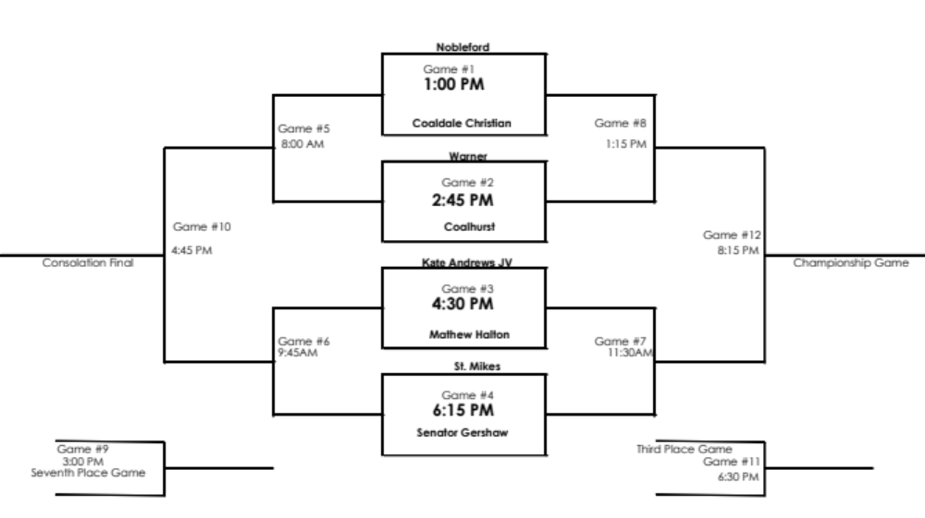
GAME # | DAY | TIME | TEAM | VS. | TEAM
1 | Friday | 1:00 p.m. |  | vs.
2 | Friday | 2:45 p.m. |  | vs.
3 | Friday | 4:30 p.m. |  | vs.
4 | Friday | 6:15 p.m. |  | vs.
5 | Saturday | 8:00 a.m. | Loser #1 | vs. | Loser #2
6 | Saturday | 9:45 a.m. | Loser #3 | vs. | Loser #4
7 | Saturday | 11:30 a.m. | Winner #3 | vs. | Winner #4
8 | Saturday | 1:15 p.m. | Winner #1 | vs. | Winner #2
9 | Saturday | 3:00 p.m. | Loser #5 vs. Loser #6
10 | Saturday | 4:45 p.m. | Consolation Final
11 | Saturday | 6:30 p.m. | Third Place Final
12 | Saturday | 8:15 p.m. | Championship Game

