**Palliser Regional Schools**

**Palliser Centre**

#101, 3305 - 18 Avenue North, Lethbridge, AB T1H 5S1

Phone: 403-328-4111 Toll-free: 877-667-1234

Fax: 403-380-6890 www.pallisersd.ab.ca

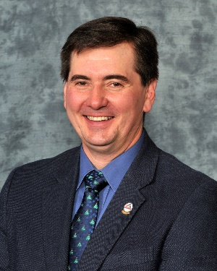

October 2015

So many reasons to be thankful

Hello everyone,

October is a season for thanksgiving, anchored in traditions of being thankful for a bountiful harvest.

While many of us are no longer directly connected to the ebbs and flows of farming, it’s always a positive process to pause and reflect on the many reasons we have to be thankful. As one of our Palliser Wall of Fame inductees suggested in 2014, “thinking is thanking.”

In Palliser, I’m grateful for the opportunity to serve our students through our work every day; for parents/guardians who are engaged partners in our schools, supporting the efforts of our teachers and school leaders; and for our staff – teachers and all those in supporting roles – who are teaching students how to learn and how to be engaged, literate citizens of the world. In doing so, they unlock the unlimited potential of our students for life.

I’m also thankful to see Palliser’s efforts being acknowledged in many ways. Later this month, members of our literacy team have been invited to present at the Second Calgary Summit, a conference for educators working to support vulnerable readers in kindergarten through Grade 4. On the very same day, our Board of Trustees have been invited to share their story on generative governance and the decision they made to provide centralized services to ensure students across Palliser have access to the supports they need. Our literacy program would not exist had the board not changed the way it ran our division about a decade ago.

Finally, I’m thankful that this month brings our first of four teacher collaboration days, when professionals from across the region meet to work in small learning groups. The topics are self-directed and groups may be united by the grade or subject they teach or by a literacy goal they share. Our first collaboration day is Oct. 13, giving our students an extra-long Thanksgiving weekend and giving our staff precious time to learn together.

As for the bountiful harvest, we can look to our outstanding student results as the crop emerging from the seeds sown by our strong school communities.

I wish you a Happy Thanksgiving!

Kevin Gietz, Superintendent

Palliser Regional Schools